Date:04.04.2022

**Third Year B. Tech., Sem VI 2021-22**

**4CS372 : Advanced Database System Lab**

**Assignment Submission**

**PRN No: 2019BTECS00064**

**Full name: Kunal Santosh Kadam**

**Batch: T2**

**Assignment: 9**

**Title of assignment: MongoDb CassandraDb**

**Objective:**

To install MongoDb and CassandraDb on windows platform and To develop a Python desktop Application to demonstrate the CRUD operation with above backend cloud databases

**Introduction & Theory:**

MongoDb:

MongoDB is an open-source document database and leading NoSQL database. MongoDB is written in C++. This tutorial will give you great understanding on MongoDB concepts needed to create and deploy a highly scalable and performance-oriented database.

Cassandra:

Cassandra is a distributed database management system which is open source with wide column store, NoSQL database to handle large amount of data across many commodity servers which provides high availability with no single point of failure. It is written in Java and developed by Apache Software Foundation.

**Procedure / Experiment:**

**Installation of MongoDb**

1. Downloading the exe file of MongoDb

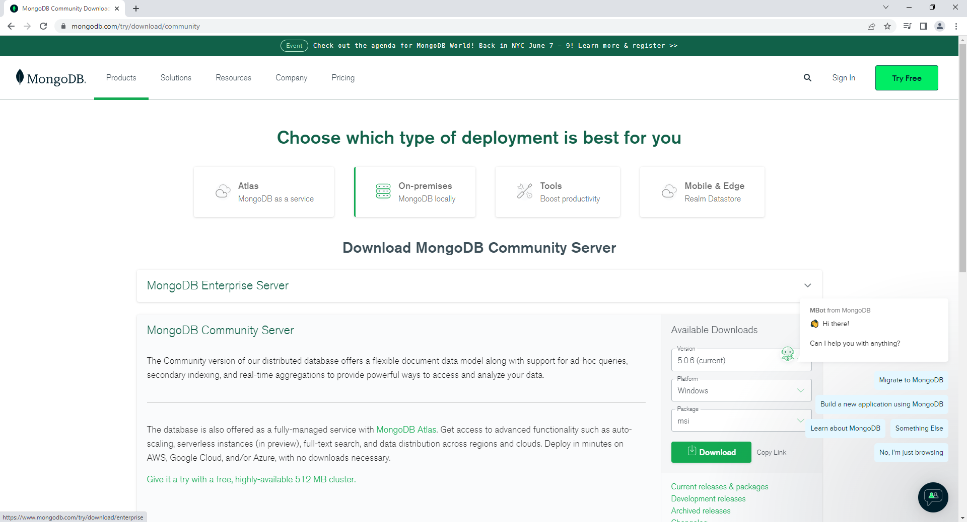

1. Installation of MongoDb

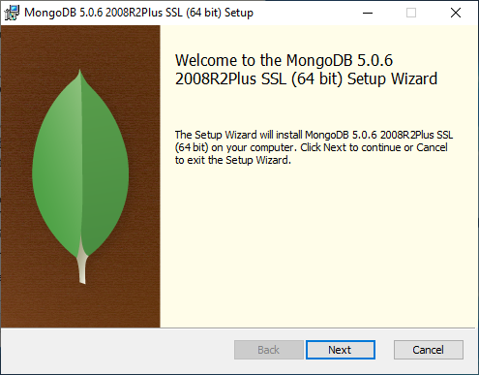

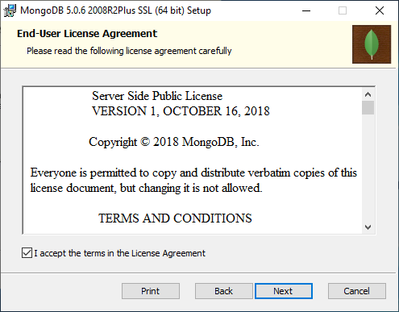

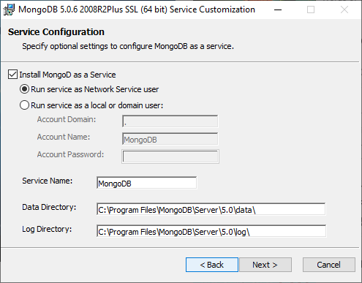

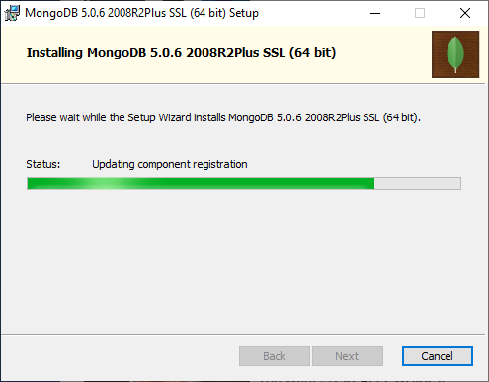

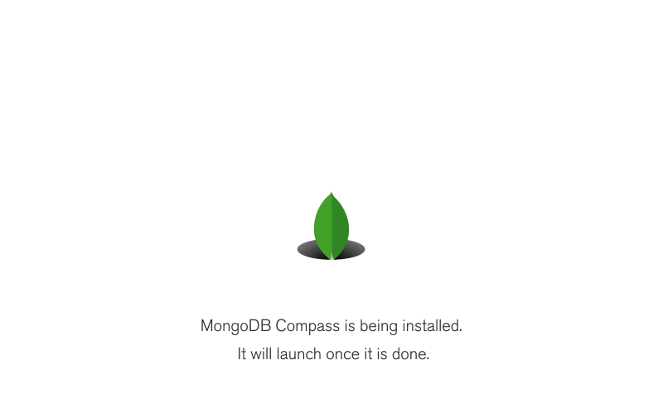

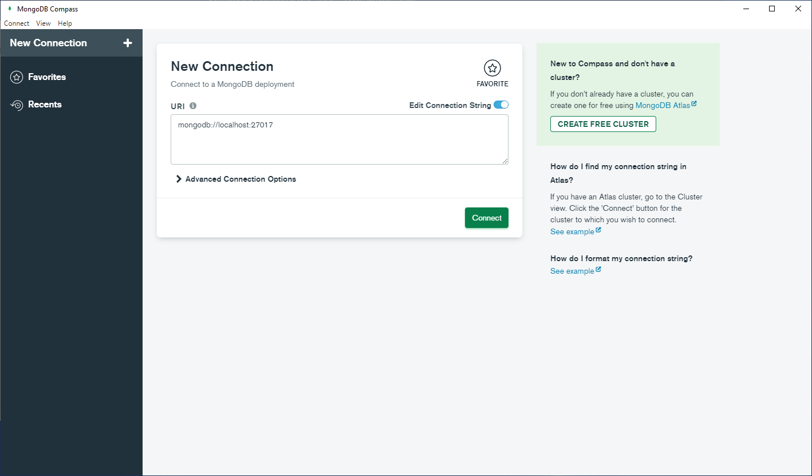

1. Setting the Environment Variables of MongoDb

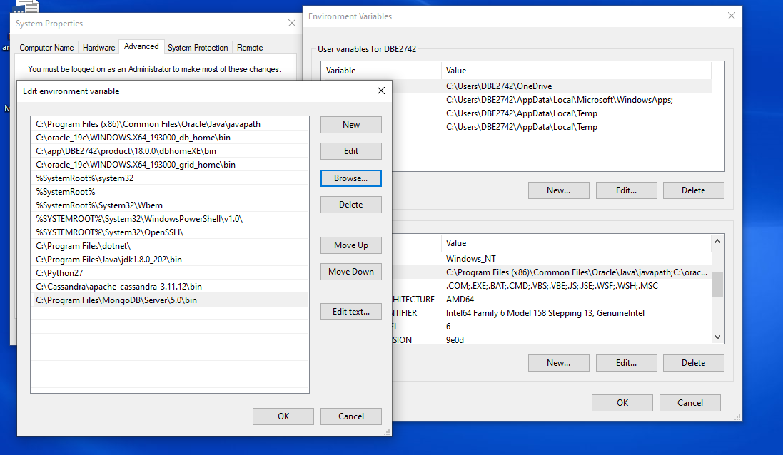

1. Running MongoDb on CMD

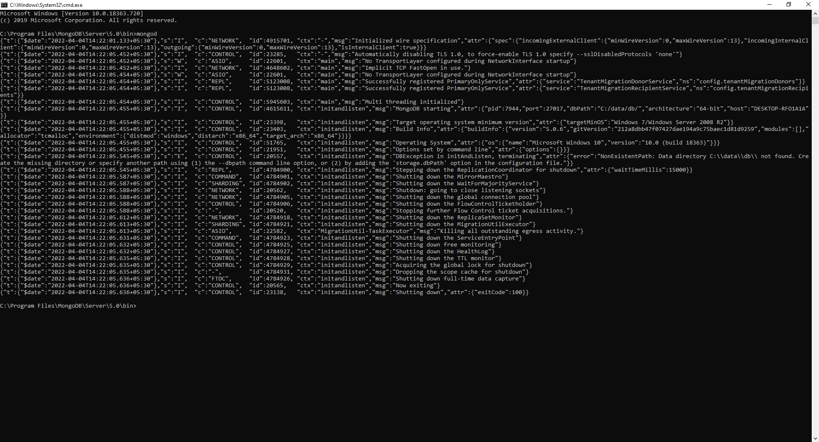

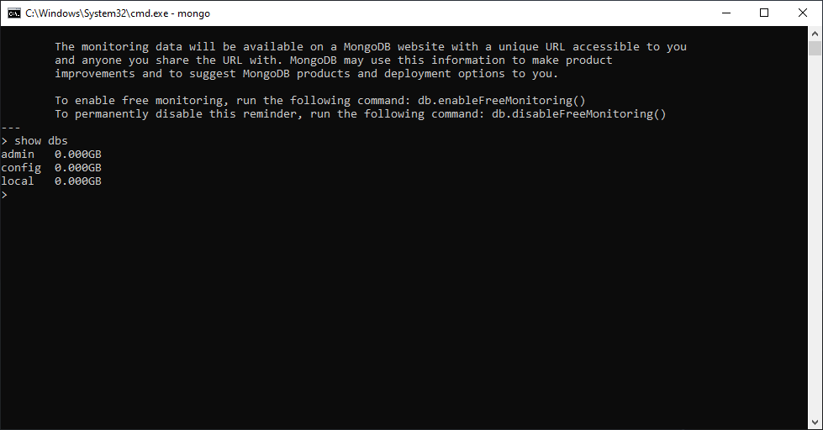

**Installation of CassandraDb:**

1. Download and Installation of Java – 8

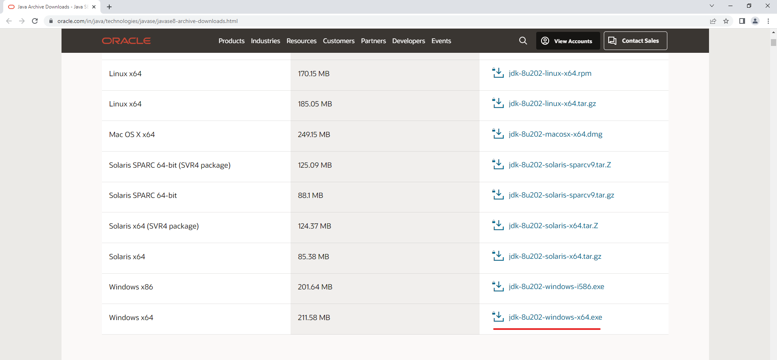

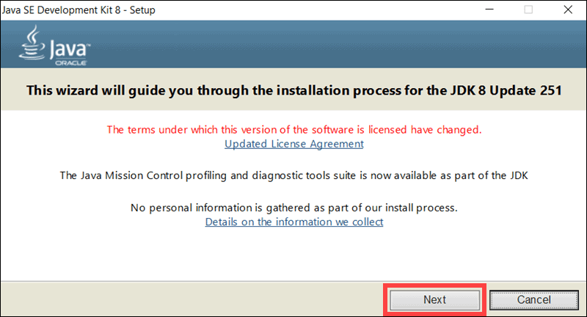

1. Configure Environment Variables for Java 8

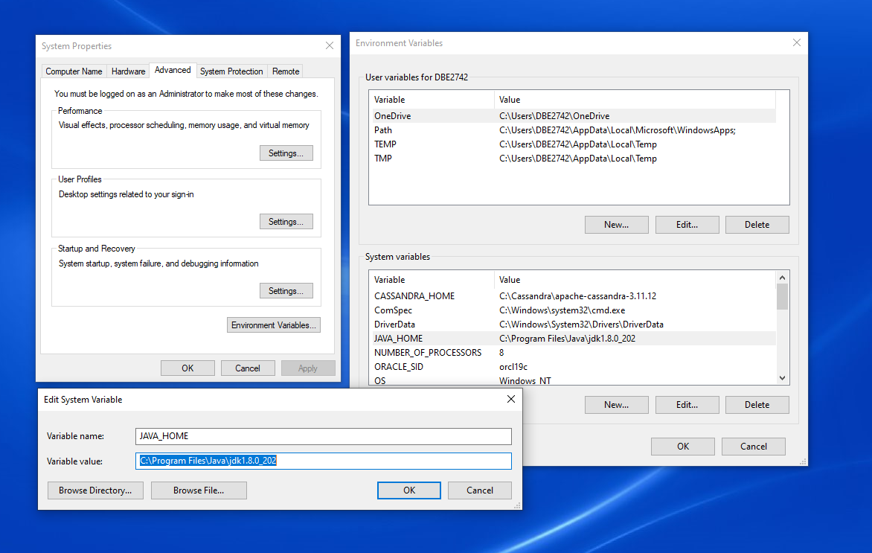

1. Download and Installation of Python 2.7

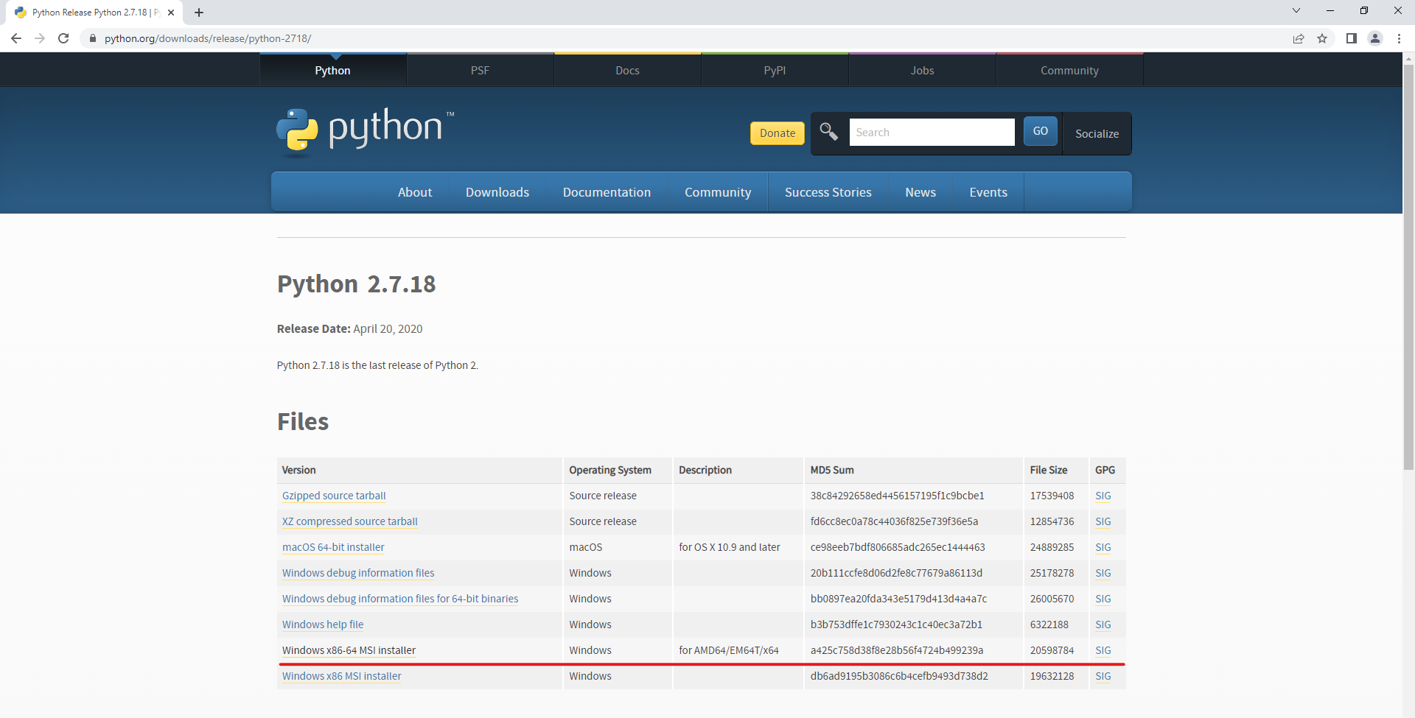

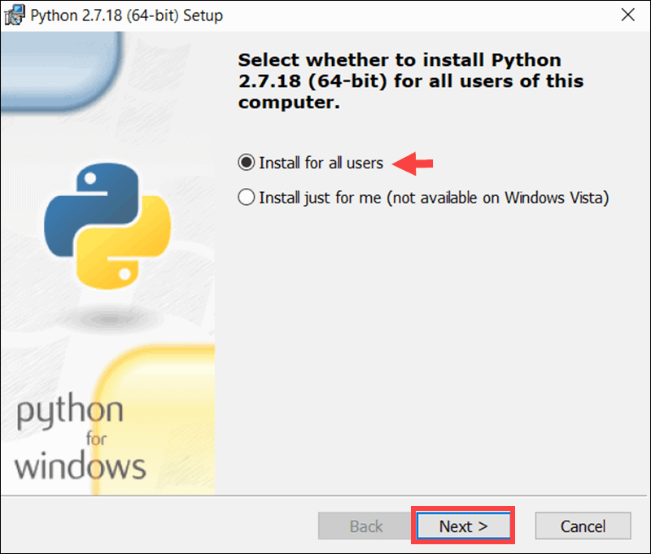

1. Configure and edit environment variable for python 2.7

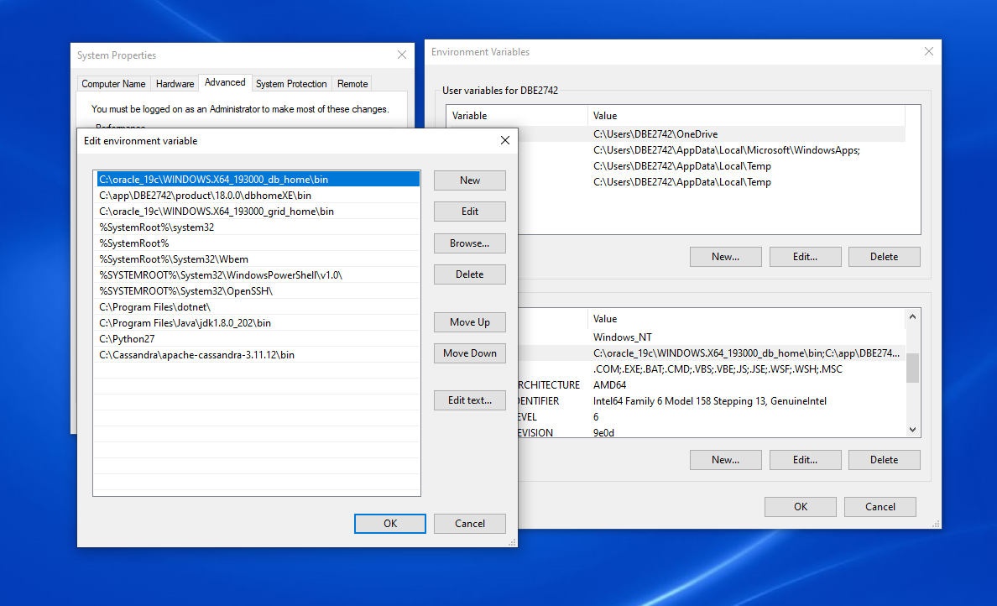

1. Download and Set Up of Cassandra

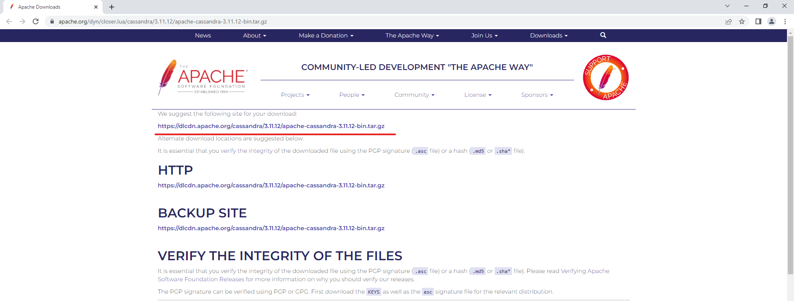

1. Configure Environment Variables for Casssandra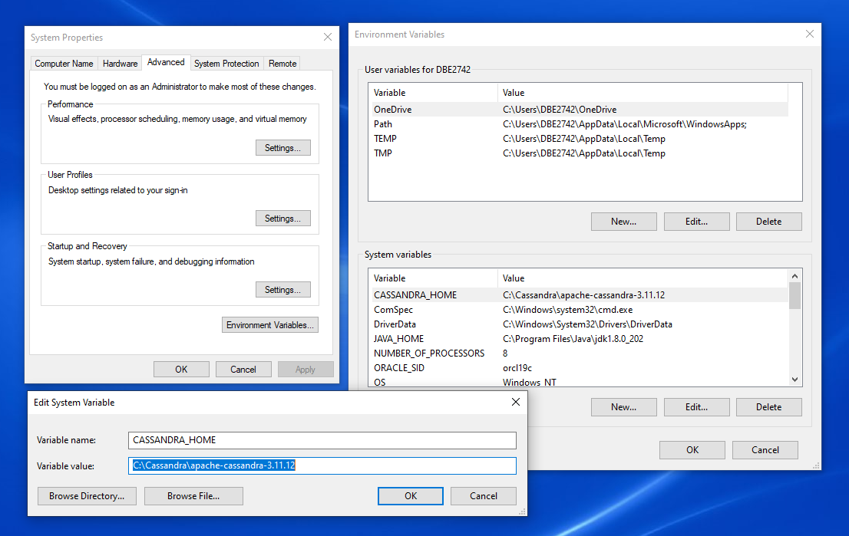

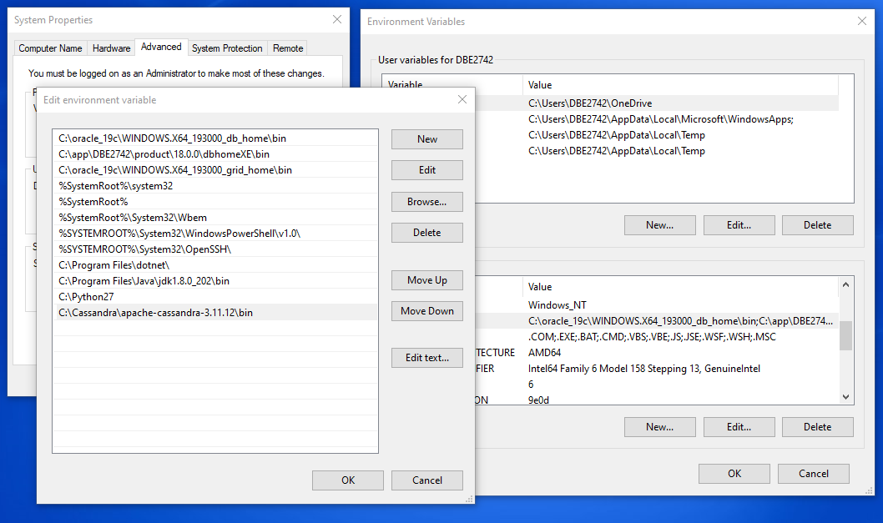

1. Start Cassandra from Windows CMD

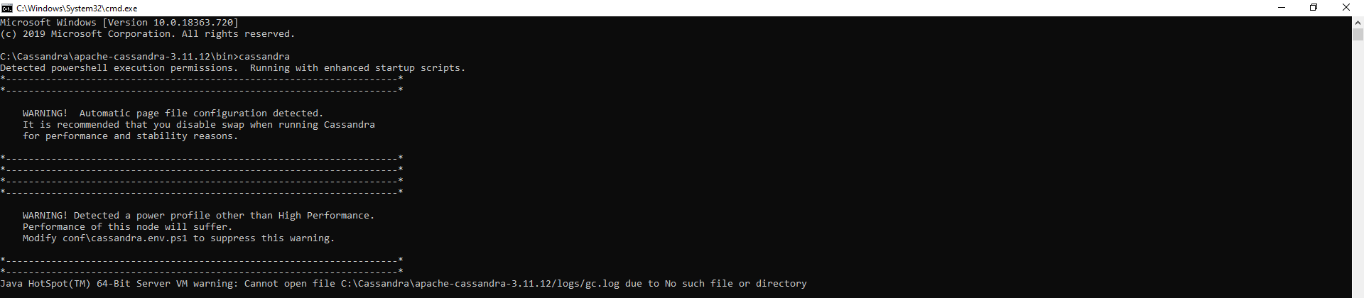

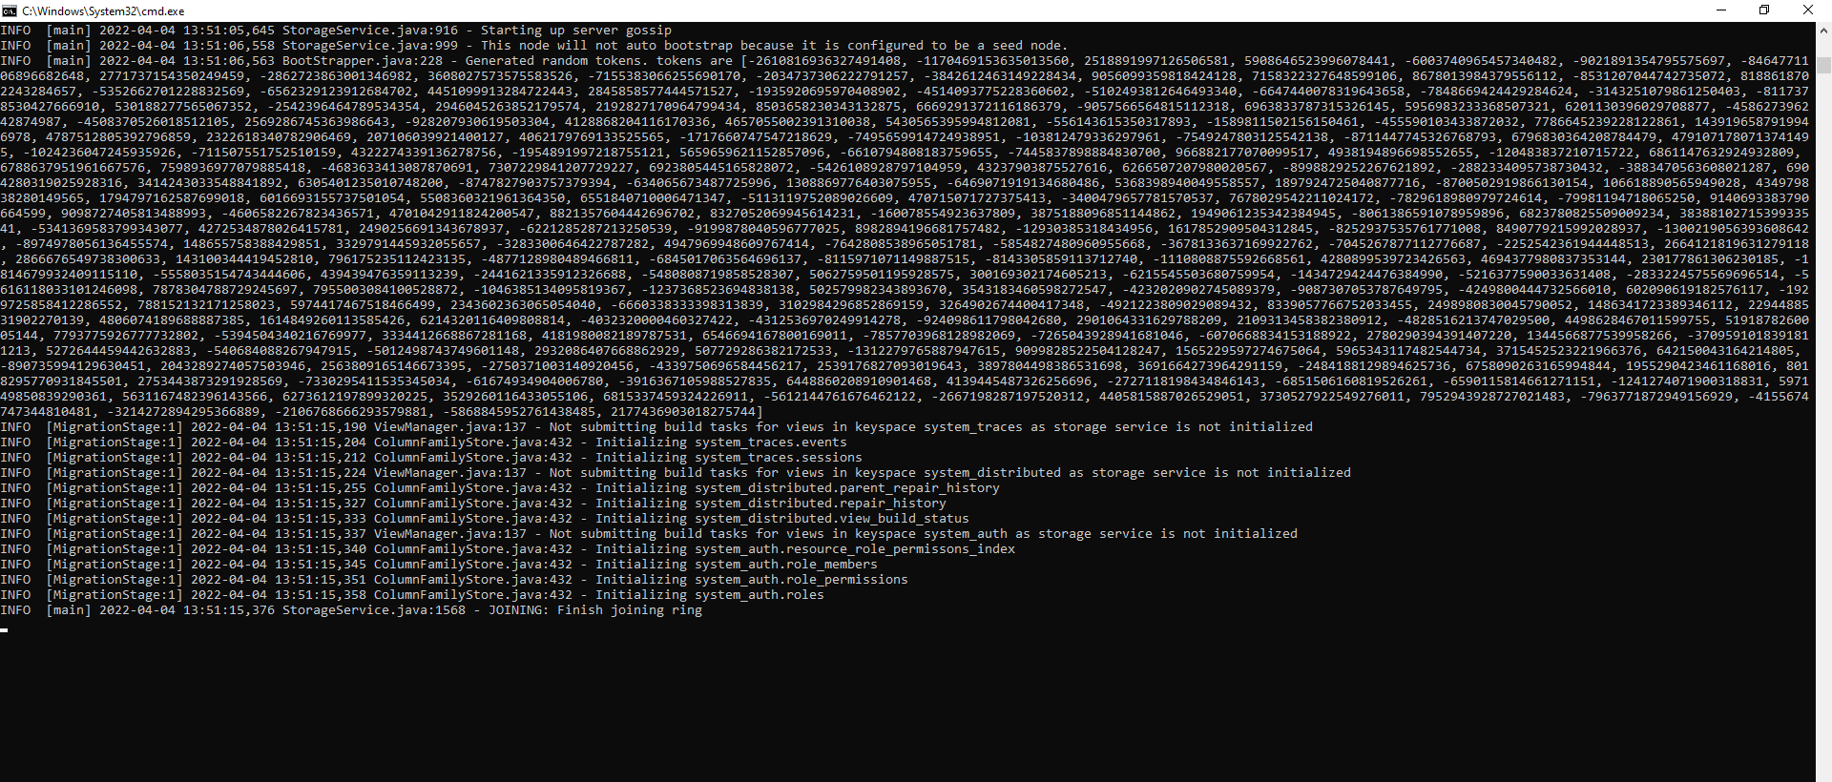

1. Access Cassandra cqlsh from Windows CMD

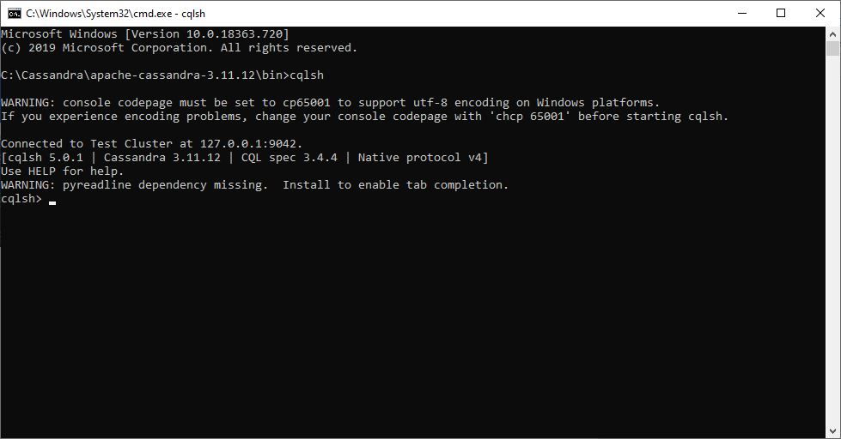

**Python Application with MongoDb Database:**

**Dashboard**

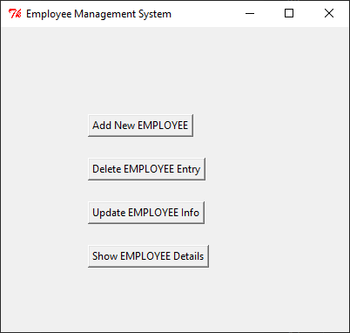

**Inserting Data**

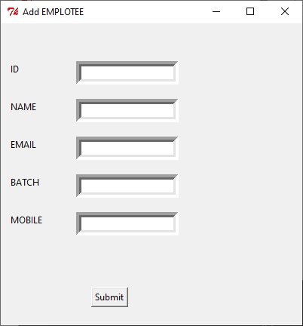

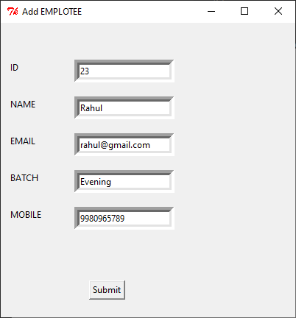

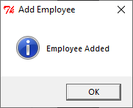

**Display data**

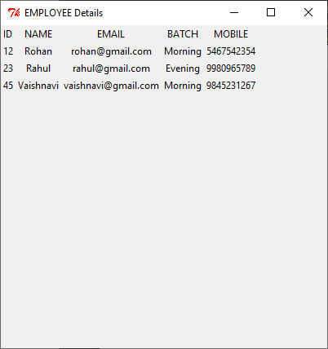

**Updating data**

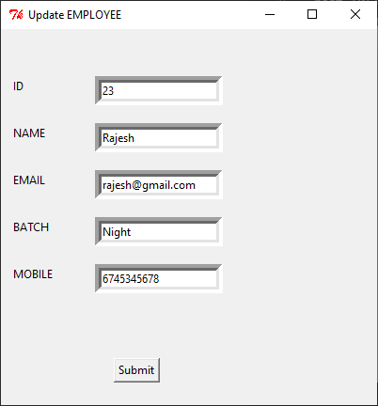

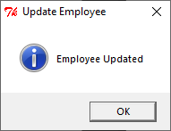

**Delete Data**

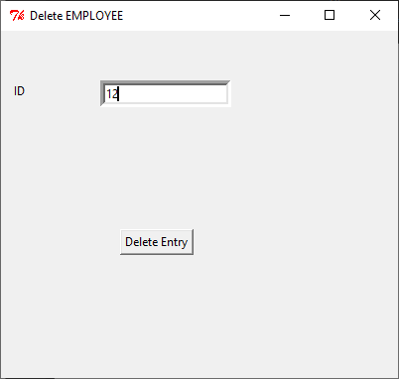

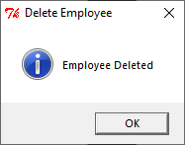

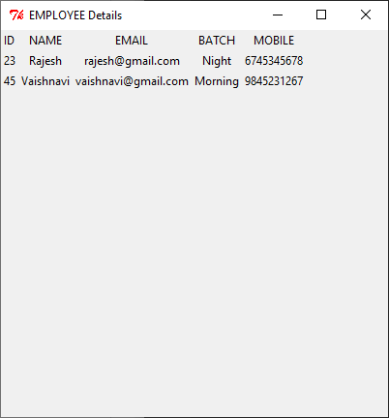

**Database in MongoDb Compass**

